Arduino Lesson 24
Relay Module
Relay is an automatic control device when the input (electrical, magnetic, acoustic, optical, thermal) reaches a certain value, the output will salutatory change. In life we often use low voltage control high voltage,such as using Arduino controller to control the high-power electrical appliances like a fan,then we need a relay, for starters, this experiment we won't use high-power electrical appliances for safety, we use LED lights to complete the demonstration experiment instead.
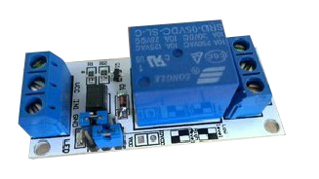
- 5v Relay Module Intro.
1、Brand new.
2、Can be used as MCU development board module, which can be used to control home appliance
3、TTL control the signal
4、Control DC/AC signal, Can control 220 v ac load
5、With normally-closed/open contact
6、With power indicator
7、With control indicator, light on when opening, off when break
8、Triode drive increase relay coil, High impedance control feet
9、Control Feet have a drop-down circuit control to prevent the impending relay wrong operation
Relay belong to signal modules, we control the high power equipment through digital signal.Here we take 2 LEDS as high power equipment.Set digital interface #8 as output,export the low level 1 second after high level delay 1 sec,which means off for 1 sec and on for 1 sec.
Connect It Up(Take below picture as example,you would know how to connect the led to the board from the former lessons)
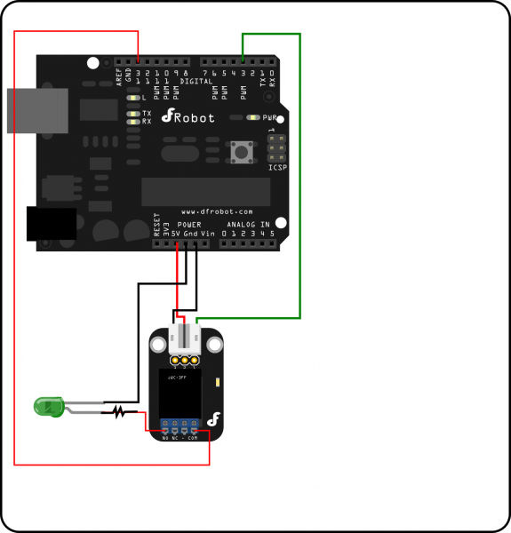
- Program for reference
int RelayPin =8; //Define digital interfase #8,connect Triode base
void setup()
{
pinMode(RelayPin, OUTPUT); //Define RelayPin interface as output
}
void loop()
{
digitalWrite(RelayPin, HIGH); //Drive the relay to be close and work.
delay(1000); //Delay 1 sec.
digitalWrite(RelayPin, LOW); //Drive the relay to be off.
delay(1000); //Delay 1 sec.
}
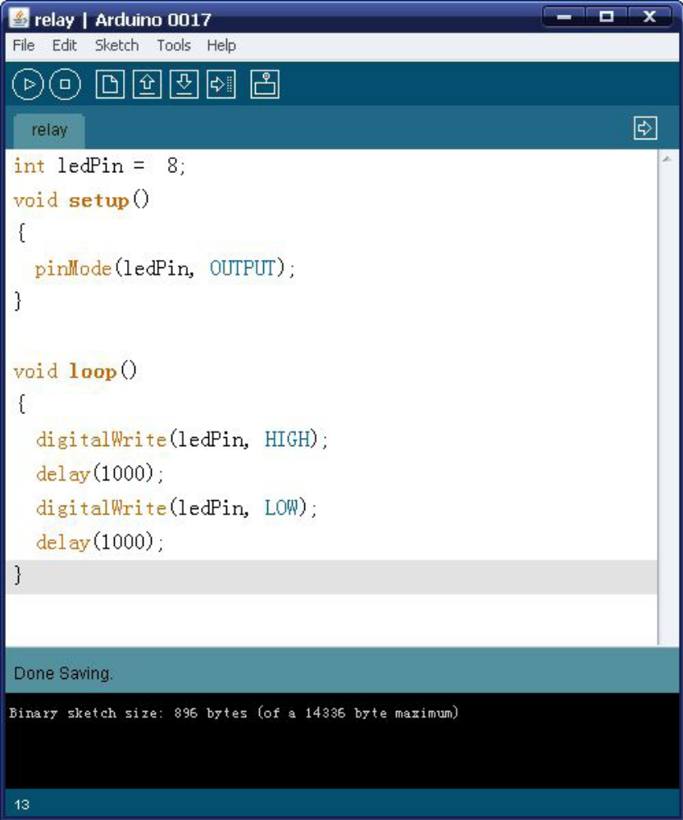
Download the program then you can see the red and green leds are flashing in turn.

